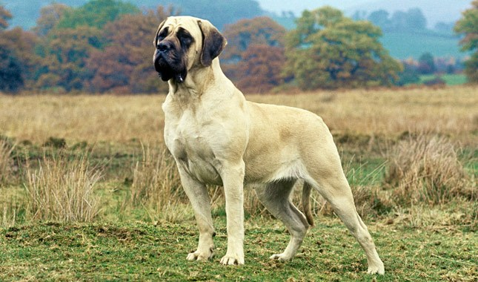

**DATA RECEIVED FOR ABOVE IMAGE IS AS FOLLOWS-**

{u'Labels': [{u'Instances': [], u'Confidence': 98.9484634399414, u'Parents': [{u'Name': u'Animal'}], u'Name': u'Pet'}, {u'Instances': [], u'Confidence': 98.9484634399414, u'Parents': [{u'Name': u'Animal'}], u'Name': u'Mammal'}, {u'Instances': [], u'Confidence': 98.9484634399414, u'Parents': [], u'Name': u'Animal'}, {u'Instances': [], u'Confidence': 98.9484634399414, u'Parents': [{u'Name': u'Mammal'}, {u'Name': u'Animal'}], u'Name': u'Canine'}, {u'Instances': [{u'BoundingBox': {u'Width': 0.4953088164329529, u'Top': 0.06242454797029495, u'Left': 0.32378342747688293, u'Height': 0.9171246886253357}, u'Confidence': 98.9484634399414}], u'Confidence': 98.9484634399414, u'Parents': [{u'Name': u'Pet'}, {u'Name': u'Canine'}, {u'Name': u'Mammal'}, {u'Name': u'Animal'}], u'Name': u'Dog'}, {u'Instances': [], u'Confidence': 85.51195526123047, u'Parents': [{u'Name': u'Pet'}, {u'Name': u'Canine'}, {u'Name': u'Dog'}, {u'Name': u'Mammal'}, {u'Name': u'Animal'}], u'Name': u'Great Dane'}], 'ResponseMetadata': {'RetryAttempts': 0, 'HTTPStatusCode': 200, 'RequestId': '7ba4e61e-742a-4659-abad-edc069594753', 'HTTPHeaders': {'date': 'Sat, 21 Dec 2019 20:58:35 GMT', 'x-amzn-requestid': '7ba4e61e-742a-4659-abad-edc069594753', 'content-length': '868', 'content-type': 'application/x-amz-json-1.1', 'connection': 'keep-alive'}}, u'LabelModelVersion': u'2.0'}

**It tells that it’s a an animal, a dog that is a mammal and its breed is great dane.**

**Similarly, we’ve done for a cat also-**

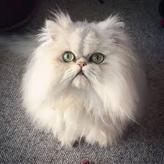

{u'Labels': [{u'Instances': [{u'BoundingBox': {u'Width': 0.8310966491699219, u'Top': 0.055169641971588135, u'Left': 0.09451720863580704, u'Height': 0.8596634864807129}, u'Confidence': 69.93712615966797}], u'Confidence': 99.81409454345703, u'Parents': [{u'Name': u'Pet'}, {u'Name': u'Animal'}, {u'Name': u'Mammal'}], u'Name': u'Cat'}, {u'Instances': [], u'Confidence': 99.81409454345703, u'Parents': [{u'Name': u'Animal'}], u'Name': u'Pet'}, {u'Instances': [], u'Confidence': 99.81409454345703, u'Parents': [], u'Name': u'Animal'}, {u'Instances': [], u'Confidence': 99.81409454345703, u'Parents': [{u'Name': u'Cat'}, {u'Name': u'Pet'}, {u'Name': u'Animal'}, {u'Name': u'Mammal'}], u'Name': u'Angora'}, {u'Instances': [], u'Confidence': 99.81409454345703, u'Parents': [{u'Name': u'Animal'}], u'Name': u'Mammal'}, {u'Instances': [], u'Confidence': 76.68433380126953, u'Parents': [{u'Name': u'Cat'}, {u'Name': u'Pet'}, {u'Name': u'Animal'}, {u'Name': u'Mammal'}], u'Name': u'Kitten'}, {u'Instances': [], u'Confidence': 62.552520751953125, u'Parents': [{u'Name': u'Animal'}, {u'Name': u'Mammal'}], u'Name': u'Rodent'}, {u'Instances': [{u'BoundingBox': {u'Width': 0.7880774140357971, u'Top': 0.07777994871139526, u'Left': 0.11359727382659912, u'Height': 0.8127653002738953}, u'Confidence': 62.552520751953125}], u'Confidence': 62.552520751953125, u'Parents': [{u'Name': u'Rodent'}, {u'Name': u'Animal'}, {u'Name': u'Mammal'}], u'Name': u'Rat'}], 'ResponseMetadata': {'RetryAttempts': 0, 'HTTPStatusCode': 200, 'RequestId': '2f269247-7b94-4f93-ae51-39e777b8cdf8', 'HTTPHeaders': {'date': 'Sat, 21 Dec 2019 21:47:09 GMT', 'x-amzn-requestid': '2f269247-7b94-4f93-ae51-39e777b8cdf8', 'content-length': '1263', 'content-type': 'application/x-amz-json-1.1', 'connection': 'keep-alive'}}, u'LabelModelVersion': u'2.0'}

**The final output put together tells us it’s a cat, indeed a kitten whose physical attributes have also been given and tells that it’s an angora cat.**

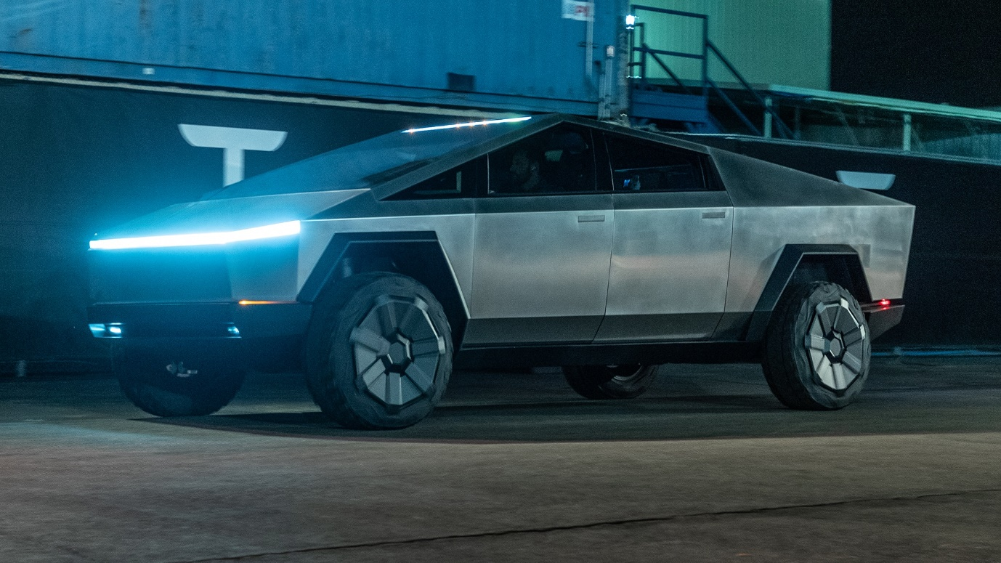

{u'Labels': [{u'Instances': [], u'Confidence': 99.90746307373047, u'Parents': [], u'Name': u'Machine'}, {u'Instances': [{u'BoundingBox': {u'Width': 0.14469969272613525, u'Top': 0.4780927896499634, u'Left': 0.3084034323692322, u'Height': 0.2778898775577545}, u'Confidence': 93.74674224853516}, {u'BoundingBox': {u'Width': 0.10821044445037842, u'Top': 0.49346983432769775, u'Left': 0.7647637128829956, u'Height': 0.2350025177001953}, u'Confidence': 63.033042907714844}, {u'BoundingBox': {u'Width': 0.12095314264297485, u'Top': 0.6366799473762512, u'Left': 0.11904366314411163, u'Height': 0.10649575293064117}, u'Confidence': 55.237831115722656}], u'Confidence': 99.90746307373047, u'Parents': [{u'Name': u'Machine'}], u'Name': u'Wheel'}, {u'Instances': [], u'Confidence': 99.84707641601562, u'Parents': [], u'Name': u'Tire'}, {u'Instances': [], u'Confidence': 99.47974395751953, u'Parents': [{u'Name': u'Tire'}, {u'Name': u'Machine'}, {u'Name': u'Wheel'}], u'Name': u'Car Wheel'}, {u'Instances': [], u'Confidence': 99.44928741455078, u'Parents': [{u'Name': u'Machine'}], u'Name': u'Spoke'}, {u'Instances': [], u'Confidence': 99.12105560302734, u'Parents': [{u'Name': u'Machine'}, {u'Name': u'Spoke'}, {u'Name': u'Wheel'}], u'Name': u'Alloy Wheel'}, {u'Instances': [], u'Confidence': 80.55438232421875, u'Parents': [{u'Name': u'Vehicle'}, {u'Name': u'Transportation'}], u'Name': u'Automobile'}, {u'Instances': [{u'BoundingBox': {u'Width': 0.8620896339416504, u'Top': 0.17509177327156067, u'Left': 0.08081859350204468, u'Height': 0.5966541767120361}, u'Confidence': 76.35689544677734}], u'Confidence': 80.55438232421875, u'Parents': [{u'Name': u'Vehicle'}, {u'Name': u'Transportation'}], u'Name': u'Car'}, {u'Instances': [], u'Confidence': 80.55438232421875, u'Parents': [{u'Name': u'Transportation'}], u'Name': u'Vehicle'}, {u'Instances': [], u'Confidence': 80.55438232421875, u'Parents': [], u'Name': u'Transportation'}, {u'Instances': [], u'Confidence': 56.82350540161133, u'Parents': [{u'Name': u'Car'}, {u'Name': u'Vehicle'}, {u'Name': u'Transportation'}], u'Name': u'Sports Car'}], 'ResponseMetadata': {'RetryAttempts': 0, 'HTTPStatusCode': 200, 'RequestId': '6802a310-bb51-430e-a81a-0067ef07b190', 'HTTPHeaders': {'date': 'Sun, 22 Dec 2019 05:17:54 GMT', 'x-amzn-requestid': '6802a310-bb51-430e-a81a-0067ef07b190', 'content-length': '1843', 'content-type': 'application/x-amz-json-1.1', 'connection': 'keep-alive'}}, u'LabelModelVersion': u'2.0'}

**The output provided tells us that the image is of a machine, that is a car used for transportation and tells it has alloy wheels.**

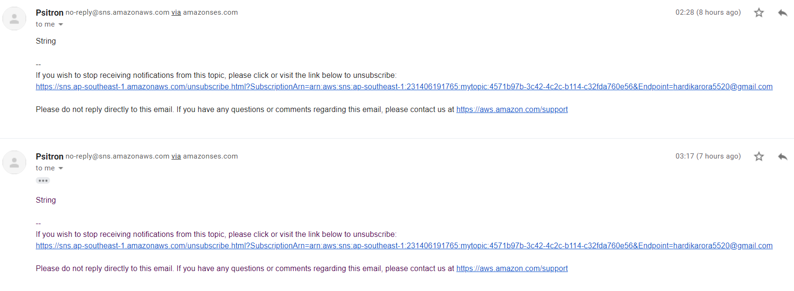

Using aws sns service to notify the user that some data has been uploaded to the S3-Database.

Here I have got mail as well as message on my mobile phone for uploading the above 2 images to the database.